Where I Come From
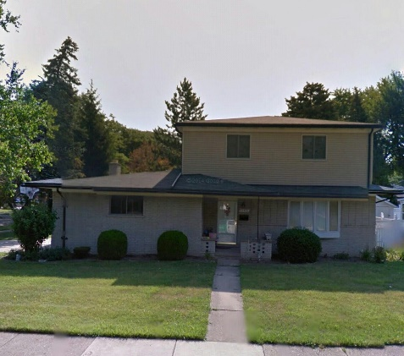
2:00PM Sunday, March 15th^{nd} West
During the summers and a few times a month, I drive 200 miles over to the East side of the state and spend some time at home in Warren, MI. Movement of People, Relative Location)
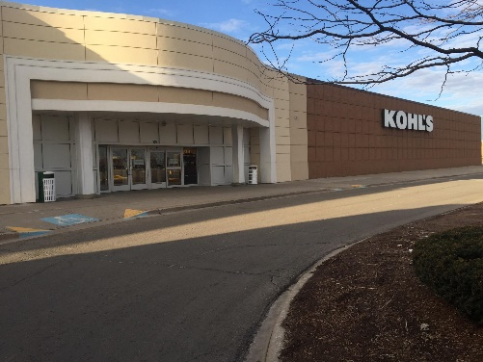
12:30PM Sunday, March 15th South
Over Christmas break, I started working at the Kohl’s back at home. This summer I will return there to work part-time. Whenever I work, I always see tons of people shopping and huge trucks delivering goods to the store (Movement of Goods, Human Economic Region)
Life at Grand Valley

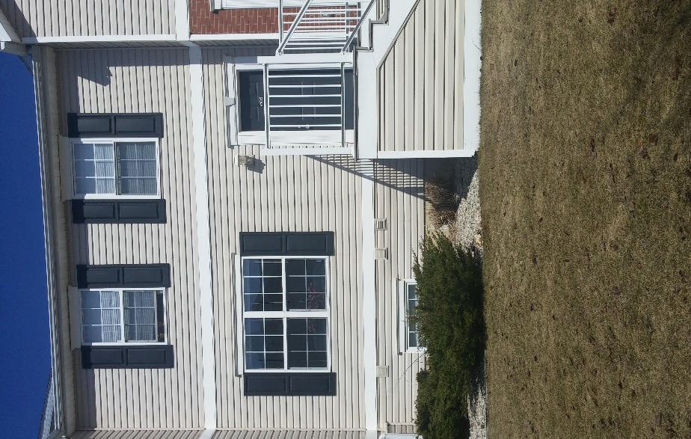
11:00AM Sunday, March 22nd Northeast
This is where I live while I’m away at GVSU, a comfortable townhouse located at unit #1234 in Copper Beech on 48th Street (Absolute Location).

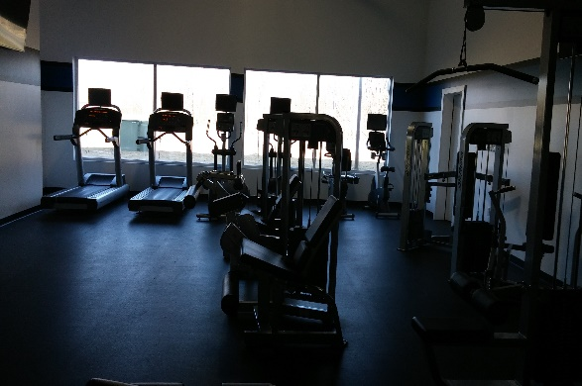
4:00 PM Sunday, March 22nd East
While I’m at school, I go to the gym every morning and listen to the radio as I work out. I also like to look out at the street and watch the cars go by. (Movement of People and Ideas)
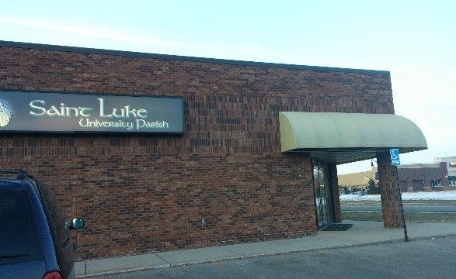
7:45PM Sunday, March 22nd Northeast
Every Sunday, I attend mass at the local Catholic Church down Lake Michigan Drive, a few miles West of GVSU campus (Relative Location, Human /Cultural Characteristics of Place)

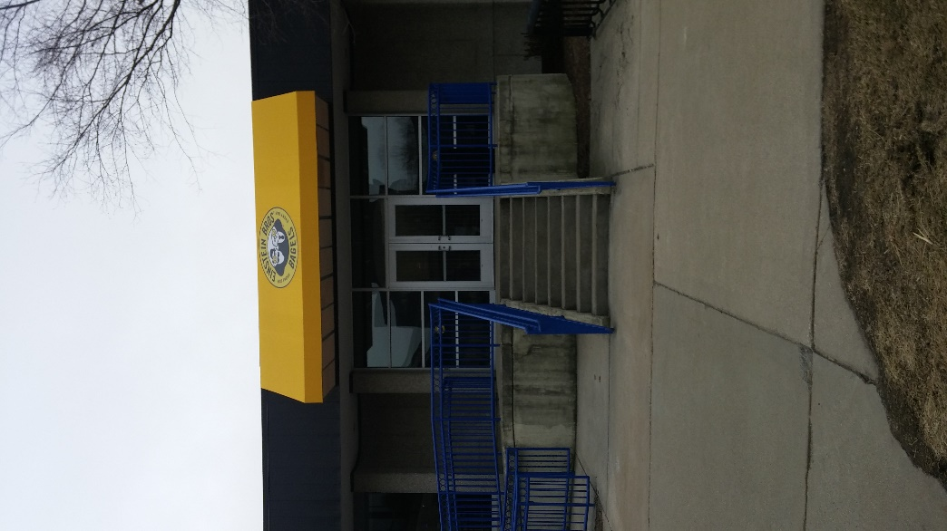
10:35AM Monday, March 23rd East
This is my favorite place to go on campus every morning. I order a coffee and bagel and sit and read the newspaper and browse the internet on my laptop (Movement of Ideas and Information).

10:30AM Monday, March 23rd Southeast
I spend most of my days at Mackinac Hall on the North side of campus, working on homework and school projects. (Relative Location, Human Characteristic of Place)
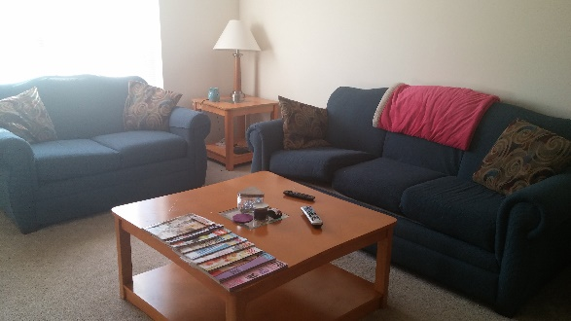
6:15 PM Monday, March 23rd Southwest
My living room is my favorite place to hang out with friends. It is located on the northeast side of my townhouse on the first floor. (Relative location)

Sunday Fun-Day
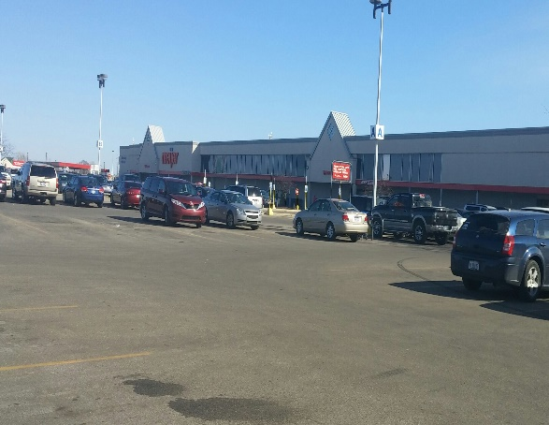
4:30PM Sunday, March 22nd Southwest
Every weekend, I stop at the Meijer on Baldwin St to shop for groceries (Absolute location).
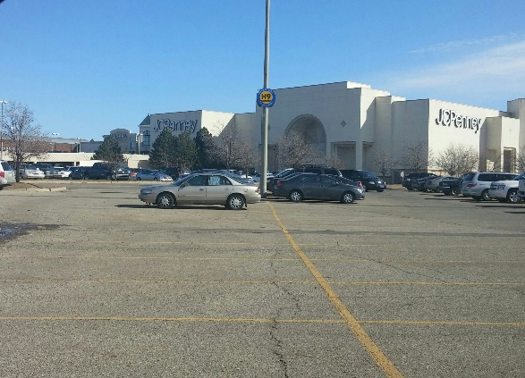
4:45PM Sunday, March 22nd Southeast
My favorite place to visit during the weekend is Rivertown Crossings Mall in Grandville. The parking lot is always packed with cars. (Human Impact, Human adaptation—i.e. Human/Environment Interaction)

