4/1/2015
The Purposes of Government & Values and Principles of American Democracy
A First Grade Civics Unit Plan Based on the Michigan GLCEs
Rebecca Wittebols
SST 309-01

Table of Contents:

Introduction/Overview/Rationale…………………………………………………………………………………………………………………………...Page 2

Grade Level Content Expectations (GLCEs) Addressed……………………………………………………………………… ……………………Page 2

Lesson One: Reasons for Rules (1-C1.0.1.)…………………………………………………………………………..…………………………………………Page 3
- KUDs/ICan Statements
- Lesson Overview

Lesson Two: Use of Power With Authority (1-C1.0.2)………………………………………………………………………………………………………Page 7
- KUDs/ICan Statements
- Lesson Overview

Lesson Three: Use of Power Without Authority (1-C1.0.3)………………………..………………..……………………………………………………Page 10
- KUDs/ICan Statements
- Lesson Overview

Lesson Four: Decisions & Resolving Conflicts (1-C2.0.1.).………………………………………..……………………………………………………… Page 13
- KUDs/I Can Statements
- Lesson Overview

Lesson Five: Vocabulary..………………………………………………………………………………………………………………………………………………Page 17

Resource Attachments (A- F)……………………………………………………………………………………………………………………………………….Page 20

Works Cited….………………………………………………………………………………………………………………………………………………………………Page 31

Unit Plan

Overview/Introduction: This unit consists of four Civics Grade Level Content Expectations for first graders, which focus on the purpose of government and why people create governments. One of the GLCEs also focuses on the values and principles at the core of our constitutional democratic government, most specifically the value of fairness, and how the government makes decisions and resolves conflicts so that we are all treated fairly. The first graders will first be introduced to the idea of rules and why they are important for us to have in school, understanding that rules are necessary. They will explore such topics as the use of authority with power in school, and also the use of authority without power in school, understanding that having authority figures in school is necessary and that people who aren’t authority figures sometimes try to impose power in a negative way. Finally, students will examine how decisions can be made and how conflicts can be resolved, understanding that conflicts need to be solved in fair and just ways.
Through completing this unit, students will gain a better understanding of our democratic nation’s constitutional government and how it operates with the goal in mind of promoting fairness for all.

Rationale: It is important that students learn about rules, authority figures, how people who are not authority figures try to impose power, and how to make decisions and resolve conflicts in fair ways because they will gain insight to how our government works to promote fairness. This unit will help students understand that our government makes rules and decisions and resolves conflicts so that the people in our country are treated fairly, and that the government has authority figures to enforce the rules. This unit will also help students understand how people who aren’t authority figures in our government might try to impose power on others, which ultimately reinforces the notion that having authority figures in our government is necessary. This lesson sets the foundation for students to later study the function of the government in protecting the basic rights we have as American citizens, and the things that the government does to ensure that our rights are not violated.

GLCE’s Addressed in this Unit:
- 1-C1.0.1- Identify some reasons for rules in school (e.g. provide order, predictability, and safety).
- 1-C1.0.2.- Give examples of the use of power with authority in school (e.g. principal, teacher, or bus driver enforcing school rules)
- 1-C1.0.3.-Give Examples of the use of power without authority in school (e.g. types of bullying, taking cuts in line).
- 1-C2.0.1.- Explain how decisions can be made or how conflicts might be resolved in fair and just ways (e.g. majority rules).

Lesson One

GLCE (coding and wording); Verb(s) underlined; type of learning: Knowledge, Skill, Reasoning, Product | 1-C1.0.1- Identify some reasons for rules in school (e.g. provide order, predictability, and safety).  Type of learning: Reasoning
Knowledge (K) | Understand (U) | DO:  Demonstration of Learning (DOL) | Vocabulary | I Can
Rules are directions that guide us how to act and behave. Rules are needed in school because they give us order, promote fairness, and create a safer environment. Order means the way something is organized or arranged (or the way something is set-up). Having rules keeps our school organized and free of chaos.  Rules also make school more predictable for students, which means that there are not big changes in the things that we do from day-to-day, so that students can count on being safe when they come to school every day. Safety means that students are not in danger of getting hurt.  Students will recognize why we must follow rules, so that we can be safe and feel safe at school and so that we can all be treated in the same fair way. | Students will understand that rules are necessary. | Students will identify reasons we have rules in school by drawing pictures of rules and writing underneath each picture why each rule is important to have (This will be done in the form of a four-tab foldable). | Rules  Safety  Order  Predictability | I can tell why we have rules in school.

Lessons: How will you take them where they need to go? (Step-by-Step plan)  Instructional strategies/Social constructs: How will they work?  (AND what will YOU do?) | Resources needed: What materials and resources will they need?  (Page #s read, graphic organizers, books, posters, realia, etc…)
Lessons:  Anticipatory Set: The teacher will read the children’s story book “Strega Nona” aloud to the class. This is a good book to introduce rules because Strega Nona has a set of rules for her cooking pot, and in the story a man uses her pot without following the rules and as a result, chaos throughout the town ensues. This is also a great book to introduce the idea of why we need rules and what would happen if we did not have rules. After the teacher reads the book, he/she will recall with the class some of the rules that Strega Nona had for her pot. Then, there will be a short class discussion about what happened when someone did not follow Strega Nona’s rules when they used her pot and some reasons for Strega Nona’s rules.  Modeling: The teacher will tell students that we follow rules wherever we go. The teacher will give an example of a rule he/she must follow and why that rule is important to follow. For example, a rule that the teacher follows when he/she is in the neighborhood or in the city is to look both ways before he/she crosses the street. The reason for this rule is to keep him/her safe so that he/she does not get hit by a car. The teacher will also explain to students that we follow rules in other places, such as at home, on the playground, in the classroom, and everywhere we go, explaining that we have rules in school because they keep us safe, help us learn, and help us work fairly and get along with other people.  Guided Practice: Students will Think, Pair, Share about examples of rules they experience in various places such as at home, in the classroom, on the playground, and when they are playing sports. The students will also discuss the reasons for these rules. After this activity, the students will gather as a class and make a list on chart paper of the different rules we follow in different places in our lives. The rules will be listed in terms easy for first-graders to understand, and there will also be a simple picture for each rule that describes each rule. This list of rules can then be posted for display either on the wall of the classroom or on a bulletin board.  Independent practice: Students will independently make a 4-tab foldable organizing the different places in their lives that they regularly encounter rules. The first page of the foldable will be labeled “Rules” and the four tabs will be labeled “Classroom,” “Recess,” “Home,” and “Sports.” For each tab, the student will (1) draw a picture of the rule, (2) describe that rule in words, (3) describe in words why we have that rule. For the written descriptions, students can either write their own simple phrases or they can describe them orally to the teacher, and the teacher can write them down.  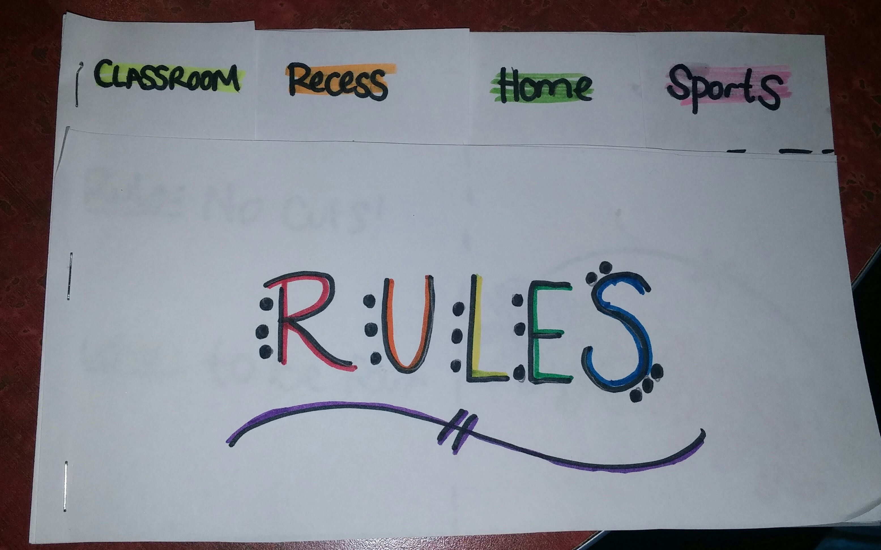  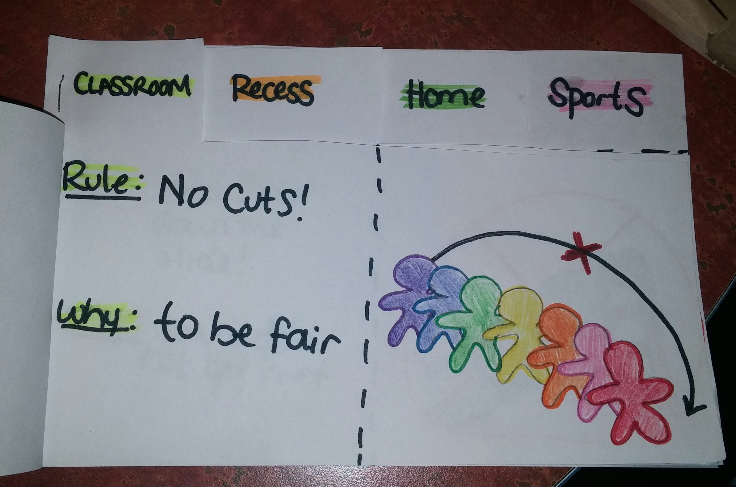  Checking for Understanding: Students will form groups of 3-4 students and share their foldables with one another. As the students do this activity, the teacher will be walking around the room to look at each of the students’ pictures and listen to their explanations of the rules and why they are necessary. | Resources needed:  - “Strega Nona” by Tomie dePaola  - Chart paper  - Large Colored markers (for chart paper)  - Crayons/markers/colored pencils  - Scissors  - stapler  - Blank pieces of paper (3 for each student) to make foldable
5. Assessment ideas: a. How will you know they’ve learned it?
Same as the check for understanding. The teacher will observe the students as they share their foldables and listen to their discussions about why the rules depicted in their foldables are necessary.
b. How will you grade it?
The students’ foldables will be graded using a checklist that checks for the following criteria: (1) Is there at least one rule for each of the four tabs? (2) Are the four tabs labeled? (3)Does the child accurately describe the rule, (4) Does the picture accurately depict the rule? (5) Is the picture neat and colorful?, (6) Does the student explain the reason(s) for each rule?

Lesson Two

GLCE (coding and wording) and Verb underlined | 1-C1.0.2.- Give examples of the use of power with authority in school (e.g. principal, teacher, or bus driver enforcing school rules)  Type of Learning: Skill/Performance
Knowledge (K) | Understand (U) | DO:  Demonstration of Learning (DOL) | Vocabulary | I Can
Authority figures are people who have power, which means they are in charge. Authority figures use their power to enforce rules, which means that they make sure that we follow the rules. Some examples of authority figures in school are Teachers, Principals, Bus Drivers, and Lunch Moms. It is an Authority figure’s job to make rules that keep us safe and make sure that we follow those rules. Authority figures also make rules to help make sure that we are always being fair. One example of a rule that an authority figure like a teacher makes is that we should go feet-first down the slide and wait in a line instead of all going down the slide at the same time. This rule helps keep us safe so that we don’t get hurt when we are going down the slide, and also makes sure that we are being fair so that everyone gets a turn to go down the slide and nobody cuts in front of other people. | Students will understand that having authority figures in school is necessary. | Given pictures of different people, students will identify which people are authority figures and give examples of how they enforce rules. (Students can do this on a worksheet and circle the authority figures). | Power  Authority  Principal  Teacher  Bus Driver  Enforce | I can tell about authority figures in school and the power they have to enforce rules.  OR  I can tell that authority figures in school make rules that are fair and that keep us safe.

Lessons: How will you take them where they need to go? (Step-by-Step plan)  Instructional strategies/Social constructs: How will they work?  (AND what will YOU do?) | Resources needed: What materials and resources will they need?  (Page #s read, graphic organizers, books, posters, realia, etc…)
Lessons:  Anticipatory Set: Students will watch the PBS Kids video “Betsey’s Kindergarten Adventures” about the rules of bus safety (This is also the video for the Vocabulary lesson). This video is a great segue into discussing the Authority figures who make the rules. After students watch the video, ask students to recall some of the rules. Then ask them “Who are the people that made the rules?” Some examples of student responses are: the teacher, the principal, the bus driver, and the mom. Ask students why these people make the rules. Explain that they make the rules because they have the power to make the rules, or they are in charge of making the rules. It is also their job to make sure that we follow the rules, so that we are safe, we can learn, and we can work together and be fair.  Modeling: The teacher will give another example of a person who is an authority figure, such as him/herself, because he/she is in charge of making the rules in the classroom and making sure that all of his/her students are following the classroom rules.  Guided Practice: The teacher will ask students to come up with other examples of authority figures that they know of, such as police officers, lunch moms, grandparents/older family members, the president, etc. As students brainstorm, the teacher will write each of the examples on the whiteboard. Then, the students will use this brainstormed list of authority figures to role play by acting out a short scene demonstrating what types of rules that authority figure enforces and how that authority figure enforces the rules. The students can split into pairs or teams of three, and each team will be assigned an authority figure to include in their skit.  Independent practice: Given pictures of different people, students will identify which people are authority figures and give examples of how they enforce rules. (Students can do this on worksheet attachment E). Students will place cutouts of authority figures in blank boxes next to or below each question as the teacher reads the questions aloud. Or for each space on the unmodified worksheet, when the teacher reads the question aloud, the student can look at the pictures and identify which authority figure answers the question, and then copy down the word under each picture on the line provided next to each question.  Checking for Understanding: After students complete the worksheet and have all of their pictures glues down or answers written, they will Mix, Freeze, Pair with a partner to compare their answers and then give examples of how each of the authority figures on their worksheet enforce rules. As students are doing this activity the teacher will be walking around and listening to the students’ explanations of what types of rules each authority figure enforces. | Resources needed:  - “PBS Kids: Betsy’s Kindergarten Adventures” video on rules of bus safety: https://www.youtube.com/watch?v=pcqsY0QGLW8  - Internet access  - Whiteboard  - Whiteboard dry-erase markers  - Think, Pair, Share Strategy instructions/description  http://www.readwritethink.org/professional-development/strategy-guides/using-think-pair-share-30626.html  - Example Skit Scenarios (Attachment A)  - Authority Figures worksheet (Attachment E)  - Pencils, glue
Assessment ideas: a. How will you know they’ve learned it? (Summative – Students demonstrate their learning.)
The same as the Checking for understanding. The teacher will be walking around listening for each pair’s discussion of examples of how each authority figure enforces rules.
b. How will you grade it?
The teacher will have a checklist looking for the following criteria: (1) does the student have each picture or label in the right place? and (2) Was the student able to give examples how each authority figure enforces rules?

Lesson Three

GLCE (coding and wording) and Verb underlined | 1-C1.0.3.-Give Examples of the use of power without authority in school (e.g. types of bullying, taking cuts in line).  Type of Learning: Skill/performance
Knowledge (K) | Understand (U) | DO:  Demonstration of Learning (DOL) | Vocabulary | I Can
Sometimes, people who don’t have authority, or who are in charge and have power to make rules, try to take charge of other people. Some examples are bullying and taking cuts in line. Bullying means teasing or being unkind to someone else. Taking cuts means not waiting your turn in line and taking someone else’s spot in line. | Students will understand that people who aren’t authority figures sometimes try to impose power in a negative way. | Students will draw a picture to give an example of when someone they know used power without having the power to or without being told to. | Power  Authority  Bullying  Taking Cuts | I can tell about times when people who aren’t authority figures try to be in charge.

Lessons: How will you take them where they need to go? (Step-by-Step plan)  Instructional strategies/Social constructs: How will they work?  (AND what will YOU do?) | Resources needed: What materials and resources will they need?  (Page #s read, graphic organizers, books, posters, realia, etc…)
Lessons:  Anticipatory Set: Read the book The Recess Queen aloud to students. After you finish reading the book, have students brainstorm some ways “Mean Jean” used power over other students in the book to get her way. Then, lead a discussion of how your  students would feel if Mean Jean was on the playground at their school and how they would handle the situation.  Compare how “Mean Jean” does not have the authority to tell students what to do that an authority figure such as a teacher or principal do, and compare how Mean Jean uses power in negative ways to how authority figures use power in positive ways  Modeling: The teacher will describe a situation in which he/ she witnessed the use of power without authority. For example, when she was playing on the playground as a kid and another student told her that she couldn’t play soccer with everyone else in the class. That student was not an authority figure, but she was acting like she had power over the teacher to prevent her from playing with everyone else.  Guided Practice: The students will pair up and do a R.A.F.T orally taking on the role of either the person without authority imposing power, or the person that the person without the authority is negatively imposing power upon. The audience will be the student’s teacher, classmates, or the “bully.” The format will be a letter to the other person or group. The topic will be how the person feels about the situation in which power without authority is imposed. Once the students are one sharing, some students can volunteer to share their oral letters with the class.  Independent practice: Students will draw a picture to give an example of when one of their peers used power without having the power to or without being told to. Then the students will describe their picture to a small group of students, the teacher, or the class.  Checking for Understanding:  The teacher will know if the student understands the concept of use of authority without power based on the student’s picture and oral description of an example of use of power without authority. | Resources needed:  - R.A.F.T. instructions  http://www.readwritethink.org/professional-development/strategy-guides/using-raft-writing-strategy-30625.html  - The Recess Queen book  - Blank piece of paper for each student (to draw picture)  - Crayons, colored pencils, markers
Assessment ideas: a. How will you know they’ve learned it? (Summative – Students demonstrate their learning.)
Same as Checking for understanding. The teacher will know if the student understands the concept of use of authority without power based on the student’s picture and oral description of an example of use of power without authority.

b. How will you grade it?
Use a checklist with the following criteria: (1) is the picture neat and colorful? (2) Does the picture depict an example of a situation of use of power without authority? And (3) Does the student’s oral description match the picture?

Lesson Four

GLCE (coding and wording) and Verb underlined | 1-C2.0.1.- Explain how decisions can be made or how conflicts might be resolved in fair and just ways (e.g. majority rules).  Type of Learning: Reasoning
Knowledge (K) | Understand (U) | DO:  Demonstration of Learning (DOL) | Vocabulary | I Can
The decisions that we make, which are how we choose to act, affect other people. When we come across a conflict, which means not agreeing with someone or having a problem with another person, we need to find ways to resolve it in a fair and just way. Resolving a conflict means finding a way to solve the problem. Resolving a conflict in a fair and just way means that each person is treated the same. One way to solve conflicts in a fair way is the idea of Majority Rules, which means that a problem is solved in a way that is fair to the most people. | Students will understand that conflicts need to be solved in fair and just ways. | Given a situation of a conflict, the student will make a poster that shows a positive, fair, and just way you of resolving the conflict. The student will come to the front of the class to share his/her poster with the class and explain his/her way of resolving the conflict based on his/her picture. | Decision  Conflict  Resolved  Fair  Just  Majority Rules | I can tell how we can make decisions that help us solve problems in a fair way.

Lessons: How will you take them where they need to go? (Step-by-Step plan)  Instructional strategies/Social constructs: How will they work?  (AND what will YOU do?) | Resources needed: What materials and resources will they need?  (Page #s read, graphic organizers, books, posters, realia, etc…)
Lessons:  Anticipatory Set: Students will watch short a Sesame Street youtube clip that introduces the idea of conflict, providing examples and nonexamples of conflict. Then the teacher will either read the Dr. Seuss story “The Zax,” or students will watch a youtube video of the story. In this story, two Zaxes are traveling in opposite directions when they get in one another’s way and both refuse to go around one another to continue on with their path. They don’t budge and never resolve their conflict, and they end up standing in the same spot for many years, never moving or compromising. This video is a great example of conflict and demonstrates what happens when we don’t resolve conflicts. After students watch both of these videos, there will be a class discussion on the types of conflicts in the videos, and the different decisions you can make to either resolve the conflict or make it worse. Discuss with students how we can all make choices to resolve conflicts in positive and fair ways by making compromises and making a choice to act in a way that is best for everyone.  Sample questions to go along with the book:  - What did each of the Zaxes want?  - What was the conflict?  - Did they get what they wanted?  - What made the conflict worse?  - What choices could they have made to resolve the conflict?  (Questions from http://www.schoolcounselingbyheart.com/2012/03/18/introduce-conflict-resolution-with-the-zax/)  Modeling: The teacher will describe a time when he/she had a conflict with another person and describe the different choices he/she had to make to solve it. The teacher will also describe how he/she made a positive choice to resolve the conflict in a fair way. An example that the teacher can give is that he/she was at the store when he/she and another person came to the same checkout line at the same time. They could have argued and fought about who was there first, or they could have made the choice to let the other person go ahead in line first. The choice that the teacher made was to let the other person go first because that person had less items in her basket, and she would make it through the line very quickly. In resolving the conflict this way, both people were able to get through checkout very quickly and without getting in a fight.  Guided Practice: Students will be asked to think about a time they had a conflict with another person and what choice they made to either resolve the conflict or make it worse. Then, students will do a Line Up Review, and discuss with their partner what the conflict was and the choice they made to resolve the conflict and the outcome that choice had in either resolving the conflict or making it worse. The pairs will then have a discussion about the different choices they could make in each situation, and then decide which choice would best resolve the given conflict in a way that is positive and fair.  Independent practice: Given a situation of a conflict, the student will make a poster that shows a positive, fair, and just way you of resolving the conflict. The student will come to the front of the class to share his/her poster with the class and explain his/her way of resolving the conflict based on his/her picture. These posters can be hung around the classroom as a reminder of how to resolve conflicts as they come up in the classroom or on the playground.  Checking for Understanding: The teacher will know if the student understands how to resolve conflicts in fair and just ways based on the student’s picture and description of how to resolve the conflict. | Resources needed:  - Sesame Street video on Conflict https://www.youtube.com/watch?v=Gl3e-OUnavQ&feature=youtu.be  - Dr. Suess The Zax youtube video https://www.youtube.com/watch?t=16&v=LaQXOrbqAbM  OR  Copy of Dr.Suess’s collection “The Sneetches and other Stories” to read “The Zax”  - Internet access  - Strategy- Line Up Review  - Source for “Hook” Questions and lesson idea http://www.schoolcounselingbyheart.com/2012/03/18/introduce-conflict-resolution-with-the-zax/  - Conflict Poster Template (Attachment F)  - Crayons, markers, colored pencils
Assessment ideas: a. How will you know they’ve learned it? (Summative – Students demonstrate their learning.)
Same as Checking for Understanding. The teacher will know if the student understands how to resolve conflicts in fair and just ways based on if the student’s picture and description of how to resolve the conflict is a fair way to resolve the conflict.
b. How will you grade it?
The teacher will use a checklist assessing the following criteria: (1) Is the poster neat and colorful? (2)Does the student describe a way to resolve the given conflict (3) Does the picture depict the student’s description of how to resolve the conflict? and (3) Does the student resolve the conflict in a fair way?

Lesson Five

Vocabulary Lessons: How will you take them where they need to go? (Step-by-Step plan)  Instructional strategies/Social constructs: How will they work?  (AND what will YOU do?) | Resources needed: What materials and resources will they need?  (Page #s read, graphic organizers, books, posters, realia, etc…)
GLCEs:  1-C1.0.1- Identify some reasons for rules in school (e.g. provide order, predictability, and safety).  1-C1.0.2.- Give examples of the use of power with authority in school (e.g. principal, teacher, or bus driver enforcing school rules).  Pre-test/Anticipatory set: the hook – introduce students to the vocabulary by playing a video about the rules of bus safety and the authority figures who make the rules.  Students will participate in whole group discussion about the vocabulary words and concepts that are present in the video, as the teacher re-introduces the words.  Lessons: How will you take them where they need to go?  Direct Instruction:  Step 1--Teacher will begin the lessons by introducing the three vocabulary words according to the script and the key concepts/terms (Safety, Rules, Authority), in the video using Marzano’s Six Steps to Building Academic Vocabulary. The video provides a context that students can relate to and draw knowledge and experience from to help make sense of the vocabulary words.  Students will watch the video and then participate in whole group discussion in which the teacher asks students to recall things that happened in the video and asks some questions such as:  - What do you think the word “safety” means?  - What are some ways that we can be safe at school or at home?  - What do you think rules are?  - What were some rules that the bus driver talked about in the video?  - Can you think of some rules you follow at home? Can you think of some rules that we follow in our classroom or on the playground? What about some rules that we follow when we go with our parents to the store?  - In the video that we watched, who were the people that made the rules or made sure that other people followed the rules?  - What do you think “authority” means?  - Can you think of any other examples of people in real life who have authority?  Students will talk with one another as they develop their understanding of the selected vocabulary words. They will also independently display their work verbally in class and visually on paper. | Resources needed: What materials and resources will they need?  - Vocabulary script (Attachment B)  - “PBS Kids: Betsy’s Kindergarten Adventures” video on rules of bus safety: https://www.youtube.com/watch?v=pcqsY0QGLW8  - internet access  - Whiteboard & Whiteboard markers  - images of Rules, Safety, and Authority figures (Attachment C)  - Three copies of the journal entry page for each student (Attachment C)  - Cutouts of speed sorting relay game pictures (Attachment D)  - Pencils & coloring utensils  Resources:  Betsy’s Kindergarten Adventures. (2014, August 22). Rules of the Road [Video file.] Retrieved from https://www.youtube.com/watch?v=pcqsY0QGLW8  Marzano, R. and Pickering, D. (2005), Building Academic Vocabulary: Teacher’s Manual, Chapter 3, “Teaching the Selected Terms.”
Step 2  Students will use the descriptions and discussions from Step 1 to formulate their own meanings of the vocabulary words. Students will explain each term in their own words as if they were explaining what the word means to a friend or family member. The students will record their personal definitions of each of these terms, write down a simple phrase or sentence including the word, and draw a picture of the word in their vocabulary journals. (This step is the written part of the vocabulary journal where the students write the meaning of the word and use it in a short sentence or phrase.) | Vocabulary Journal Entry Page (Attachment C)
Step 3  Along with their written meanings and sentence/phrase of each vocabulary word, students will also draw a visual representation of the word(s) on their journal entry pages. | Vocabulary Journal Entry Page (Attachment C)
Step 4  Students will review their knowledge and understanding of the new vocabulary through the “Free Association Activity.” When given the vocabulary word, students will say the first word that they think of when they hear that term. Call out the term and ask students to take turns (by raising their hands) calling out words associated with the vocabulary word. After a minute or so, say “stop.” The last student that said a word has to explain how that word relates to the vocabulary term. | Marzano, R. and Pickering, D. (2005), Building Academic Vocabulary: Teacher’s Manual, Chapter 4, “Review Activities and Games.”
Step 5  After students finish their vocabulary journal entries, have them turn to their partner or their group to share their definitions, pictures, and sentences. Have students compare their definitions to get more ideas of what each of the vocabulary words mean. | Completed Vocabulary Journal Entries (Attachment C)
Step 6  For this portion of the lesson, we will play a speed sorting relay game in which teams of students will race to sort pictures according to the vocabulary word they best fit. The students will be split up into two or more teams, facing the whiteboard. The students should have ample space to move—about 6-10ft of free space in front of them. Each part of the whiteboard will be divided into three categories—one for each vocabulary word, and each team will have their own set of three words to fill out. The students will be instructed to stand in a straight line with each player taking turns picking up a picture, running up to the board, and placing the picture under the right vocabulary word. Then the student must run back and “tag” his/her next teammate in line to run up and another picture. The team who sorts all of the pictures the fastest and places all of the pictures in the right category wins the game! | Cutouts of speed sorting relay game pictures (Attachment D)

Resource Attachments:

Attachment A:
Example Skit Scenarios:
- A teacher assigning homework/ classwork to his/her class.
- A parent telling children to do their chores.
- A police officer giving someone a ticket.
- A principal telling students to eat quietly in the cafeteria.

Attachment B:
A Script for Vocabulary Development

As an introduction to the three vocabulary words Safety, Rules, and Authority, students will watch a PBS video titled “Rules of the Road.” This video pairs well with these vocabulary words because in the video there are four examples of characters who are authority figures, a mother, a bus driver, a principal, and a teacher. In the video, the authority figures make rules for the students to follow, and when the students in the video do not follow the rules, they get into a little bit of trouble. Later in the video, there is a segment on rules and bus safety. Students will really enjoy this video, as it is both fun and engaging, and the video does an excellent job of providing situational context that students can both relate to and draw experience from as you introduce them to the vocabulary.

Show a “PBS Kids: Betsy’s Kindergarten Adventures” video on rules of bus safety: https://www.youtube.com/watch?v=pcqsY0QGLW8

Safety:
Teacher-talk (Step One): What did you all think about the video? Did you like it? I liked it too, but there were a few words in the video that I didn’t really know. Maybe we can figure out what they mean together. One of the words in the video that I didn’t really know was “safety.” The bus driver talked about bus safety and ways the students could be safe when they were riding on the bus. The principal, Teacher, and parent also talked about ways to be safe at home, at school, and in the classroom. What do you think that the word “safety” means? (Give students some time to answer.) Safety means that students are not in danger of getting hurt. What are some ways that we can be safe at school or at home? (Give students some time to answer). There are many ways that we can make sure we are being safe. Safety is very important!

Step 2 - Building Academic Vocabulary: Write in your own words the meaning of “Safety.”
Teacher-talk: One word that we learned today is “Safety” How would you tell someone in your family what that word means?

The students will record their personal definitions of each of these terms and write down a simple phrase or sentence including the word. (This step is the written part of the vocabulary journal where the students write the meaning of the word and use it in a short sentence or phrase.)

Step 3 - Building Academic Vocabulary: Draw a picture of something that shows you know the meaning of “Safety.”
Along with their written meanings and sentence/phrase of each vocabulary word, students will also draw a visual representation of the word(s) on their journal entry pages.

Rules:
Teacher-talk (Step One): In the video, the bus driver made a list of things the students had to do to be safe on the bus. He called the things on his list “rules.” What do you think rules are? (Give students some time to answer). Rules are directions that guide us how to act and behave. They are instructions that we follow to keep ourselves and other people safe. What were some rules that the bus driver talked about in the video? (Students will answer. You might need to replay this part of the video to give the kids a refresher.) We also follow rules in other places besides on the bus, like at home, at the store, in the classroom, and on the playground. Can you think of some rules you follow at home? Can you think of some rules that we follow in our classroom or on the playground? What about some rules that we follow when we go with our parents to the store? (Give students some time to share some examples).One example of a rule that I can think of that we follow on the playground is that we should go feet-first down the slide and wait in a line instead of all going down the slide at the same time. This rule helps keep us safe so that we don’t get hurt when we are going down the slide, and also makes sure that we are being fair so that everyone gets a turn to go down the slide and nobody cuts in front of other people. That is what rules do—they are made to keep us all safe and to make sure that we are being fair!

Step 2 - Building Academic Vocabulary: Write in your own words the meaning of “Rules.”
Teacher-talk: One new word that we learned today is “Rules.” How would you tell someone in your family what that word means?

The students will record their personal definitions of each of these terms and write down a simple phrase or sentence including the word. (This step is the written part of the vocabulary journal where the students write the meaning of the word and use it in a short sentence or phrase.)

Step 3 - Building Academic Vocabulary: Draw a picture of something that shows you know the meaning of “Rules.”
Along with their written meanings and sentence/phrase of each vocabulary word, students will also draw a visual representation of the word(s) on their journal entry pages.

Authority:
Teacher-talk (Step One): Now we know that we have rules to keep us safe, but who makes the rules? Do you make the rules? Does your dog or cat make the rules? (Students will answer No!) In the video that we watched, who were the people that made the rules or made sure that other people followed the rules? (Give students time to respond. Ex: mother, bus driver, principal, teacher.) People who make rules have something called “authority.” What do you think that “authority” means? (Give students some time to answer). Authority means having power, or being in charge. People who have authority use their power to make sure that we follow the rules. Can you think of any other examples of people in real life who have authority? (Students will answer. Ex: father, grandma, grandpa, president, police officer, lunch mom, etc.) It is a person with authority whose job it is to make rules that keep us safe and make sure that we follow those rules, just like how the people with authority like the teacher, mother, bus driver, and principal in the video made sure that all of the students followed the rules.

Step 2 - Building Academic Vocabulary: Write in your own words the meaning of “Authority.”
Teacher-talk: One new word that we learned today is “Authority.” How would you tell someone in your family what that word means?

The students will record their personal definitions of each of these terms and write down a simple phrase or sentence including the word. (This step is the written part of the vocabulary journal where the students write the meaning of the word and use it in a short sentence or phrase.)

Step 3 - Building Academic Vocabulary: Draw a picture of something that shows you know the meaning of “Authority.”
Along with their written meanings and sentence/phrase of each vocabulary word, students will also draw a visual representation of the word(s) on their journal entry pages.

All three words (Safety, Rules, Authority)
Step 4 - Building Academic Vocabulary: Do activities that allow students to work with the words.
Students will review their knowledge and understanding of the new vocabulary through the “Free Association Activity” (Marzano) When given the vocabulary word, students will say the first word that they think of when they hear that term. Call out the term and ask students to take turns (by raising their hands) calling out words associated with the vocabulary word. After a minute or so, say “stop.” The last student that said a word has to explain how that word relates to the vocabulary term.

Step 5- Building Academic Vocabulary: Students talk with one another about the words
After students finish their vocabulary journal entries, have them turn to their partner or their group to share their definitions, pictures, and sentences. Have students compare their definitions to get more ideas of what each of the vocabulary words mean.

Step 6 - Building Academic Vocabulary: Play games with the words they are learning.
For this portion of the lesson, we will play a speed sorting relay game in which teams of students will race to sort pictures according to the vocabulary word they best fit. The students will be split up into two or more teams, facing the whiteboard. The students should have ample space to move—about 6-10ft of free space in front of them. Each part of the whiteboard will be divided into three categories—one for each vocabulary word, and each team will have their own set of three words to fill out. The students will be instructed to stand in a straight line with each player taking turns picking up a picture, running up to the board, and placing the picture under the right vocabulary word. Then the student must run back and “tag” his/her next teammate in line to run up and another picture. The team who sorts all of the pictures the fastest and places all of the pictures in the right category wins the game!

Attachment C—(Vocabulary Journal Entry page)

Word | Meaning
Sentence/Phrase | Picture

Attachment D- Speed Sorting Relay Race Game Pictures
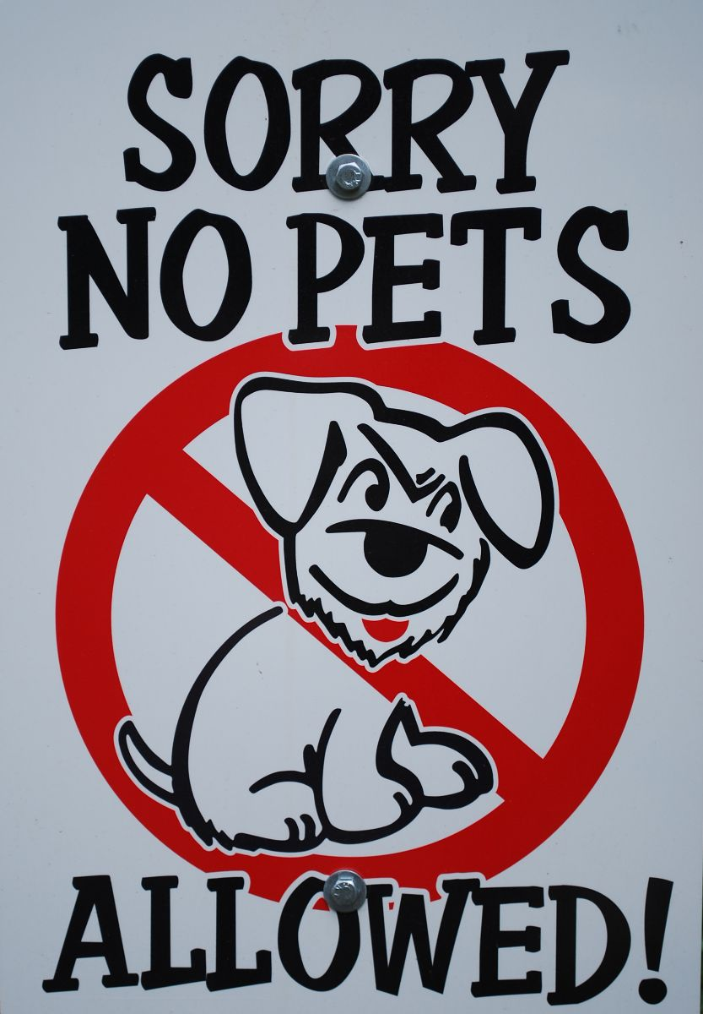

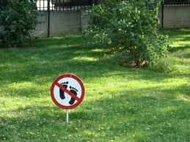

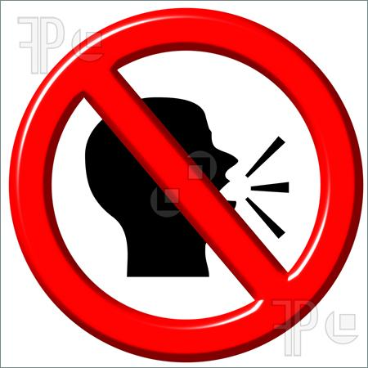

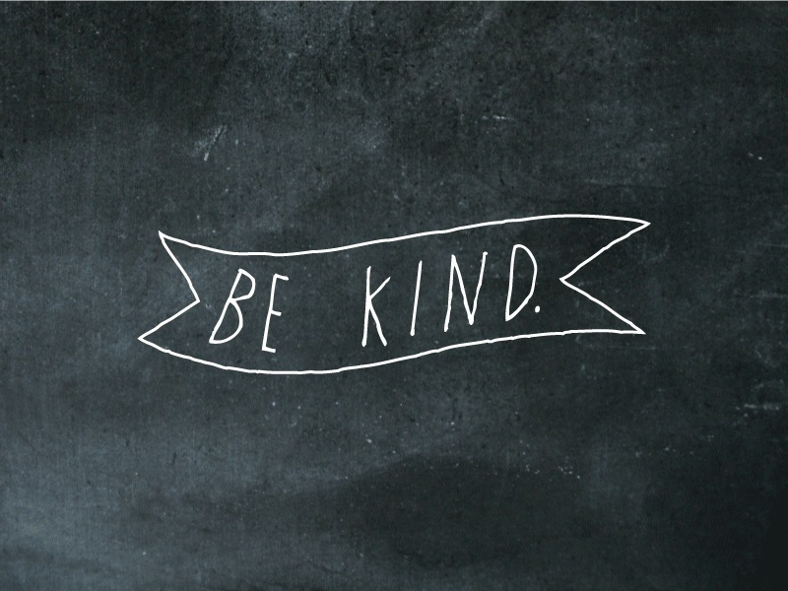

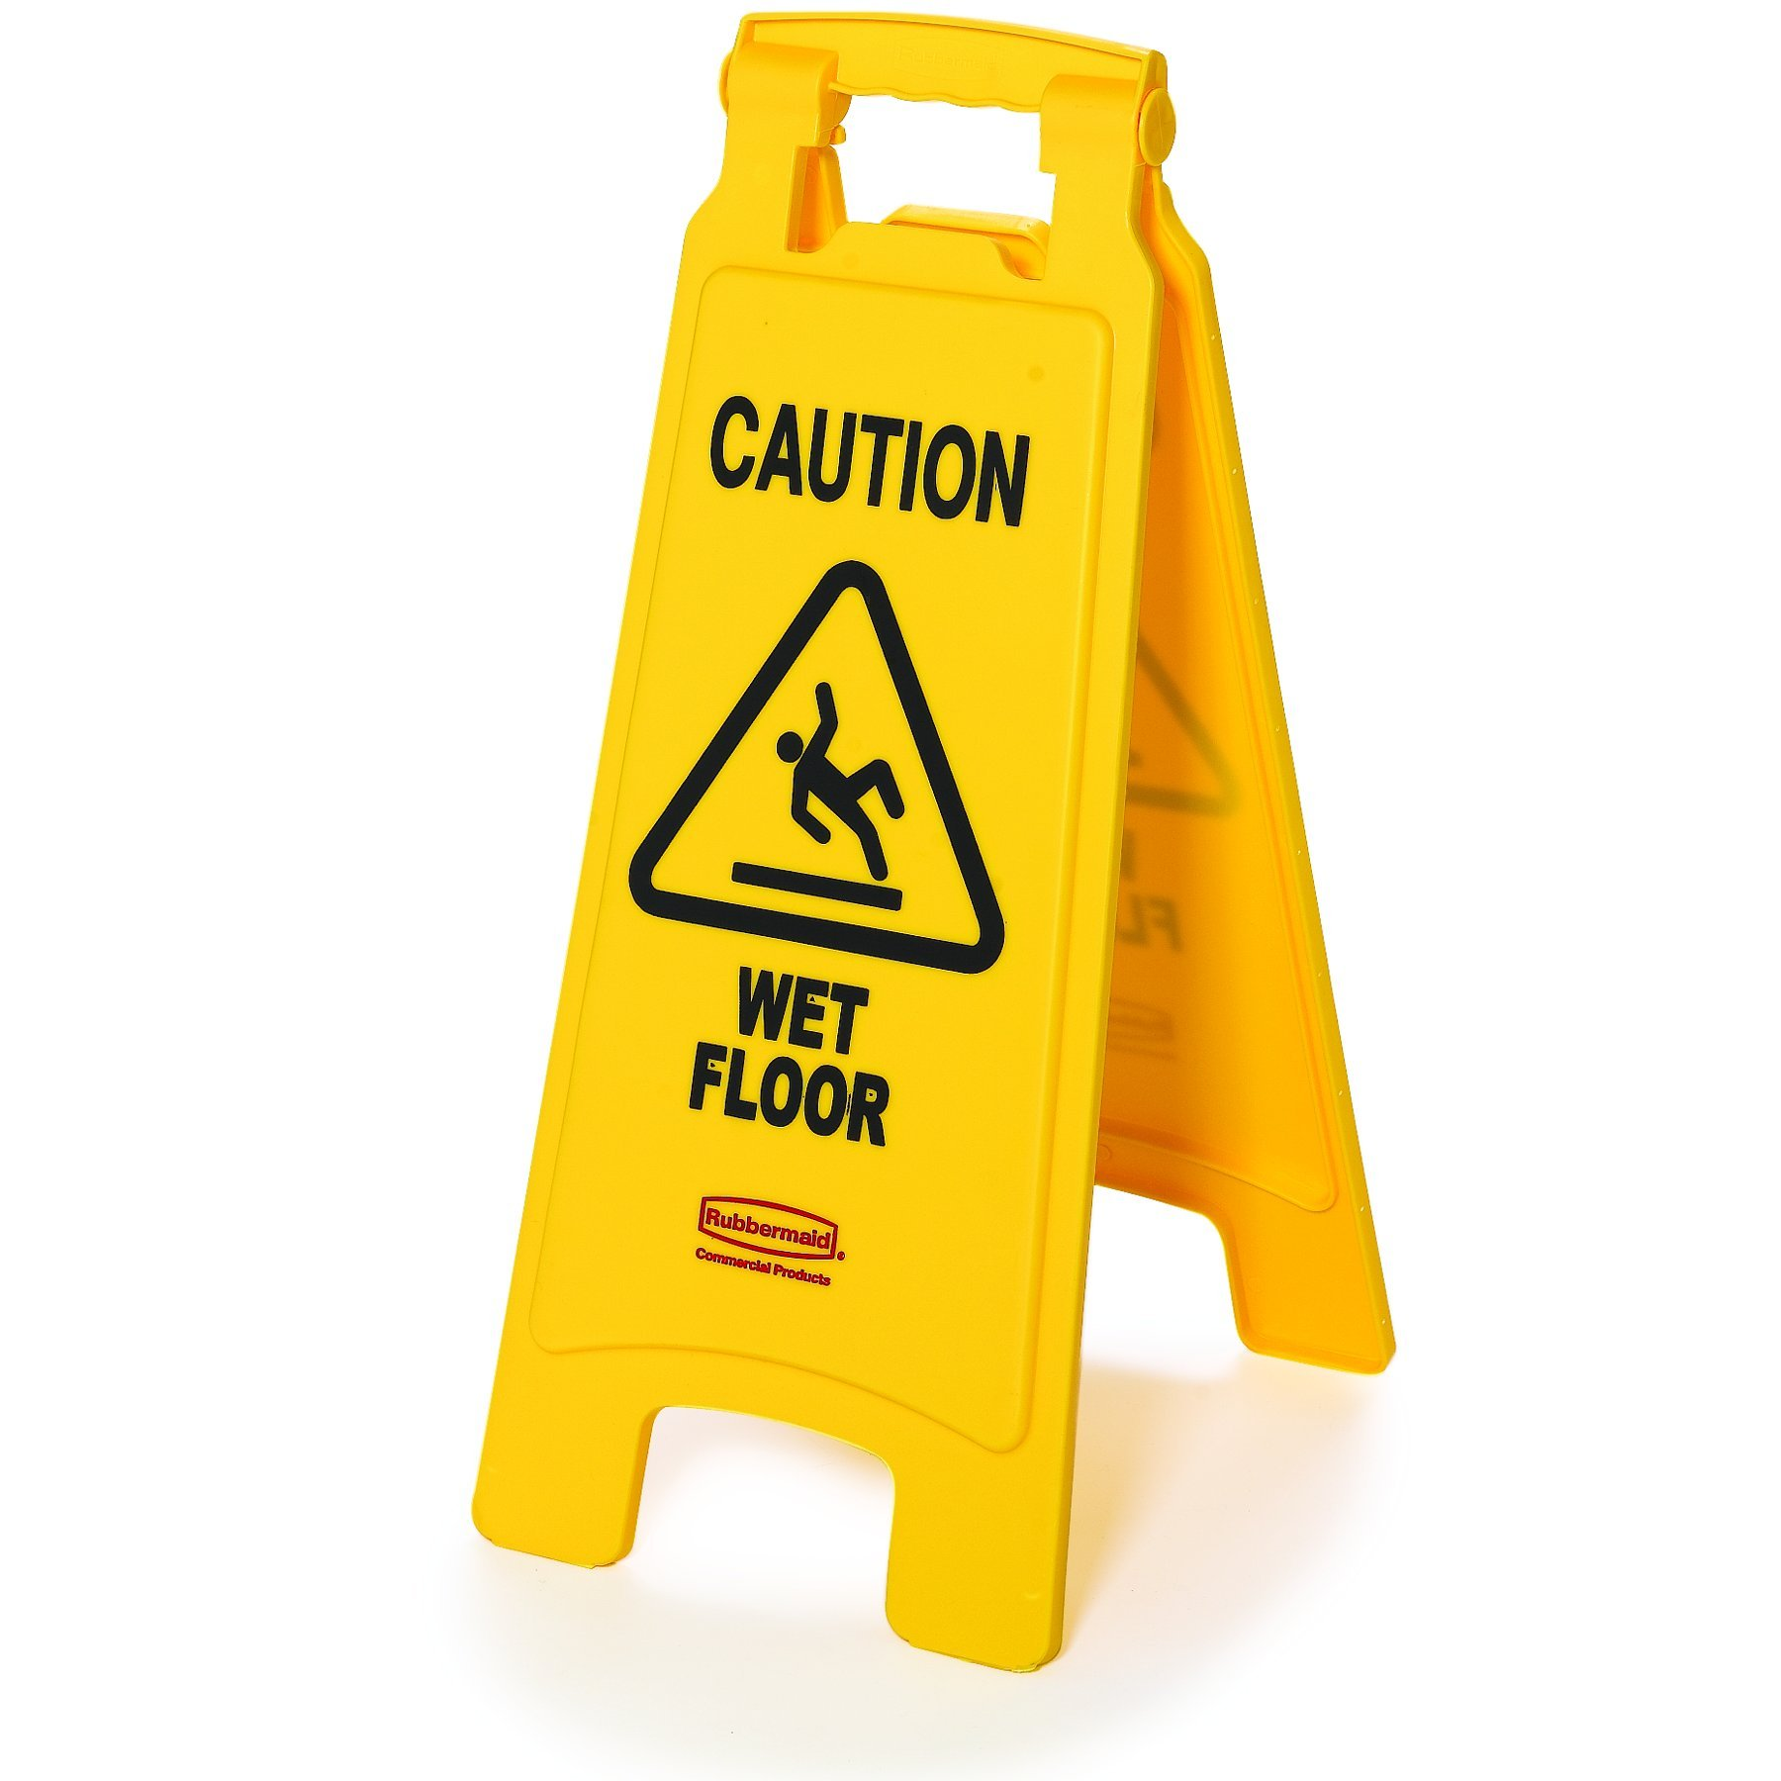
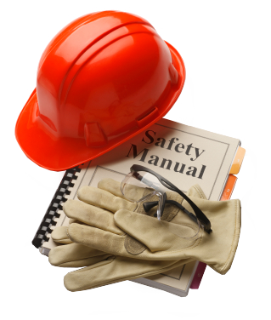
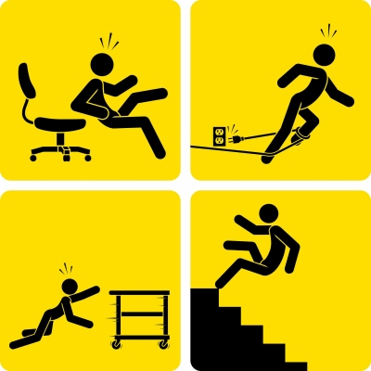

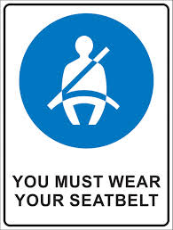

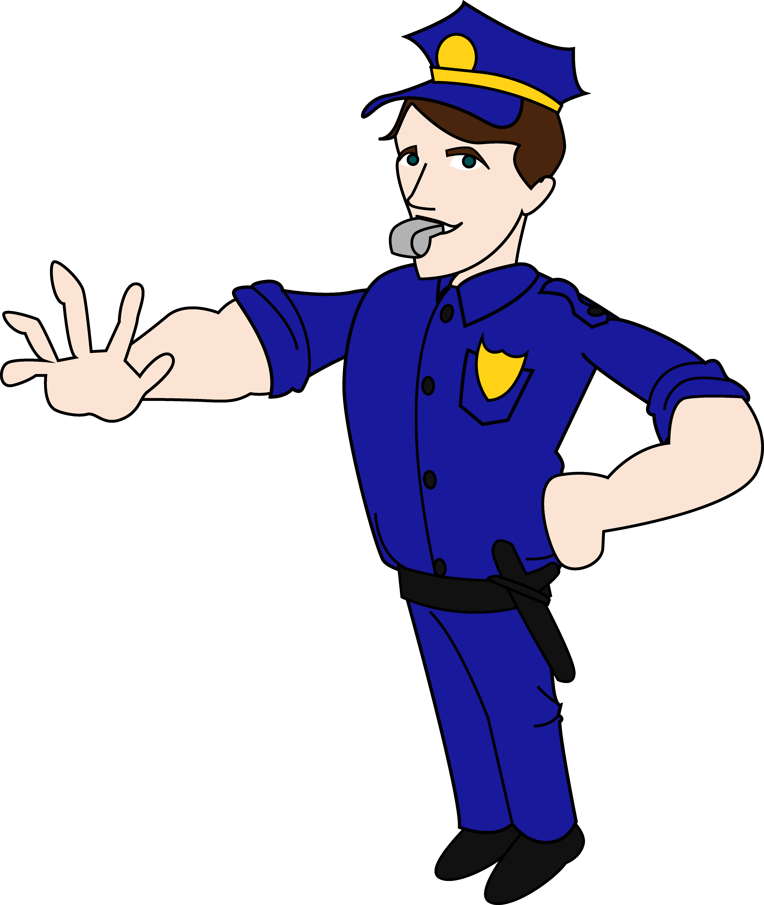

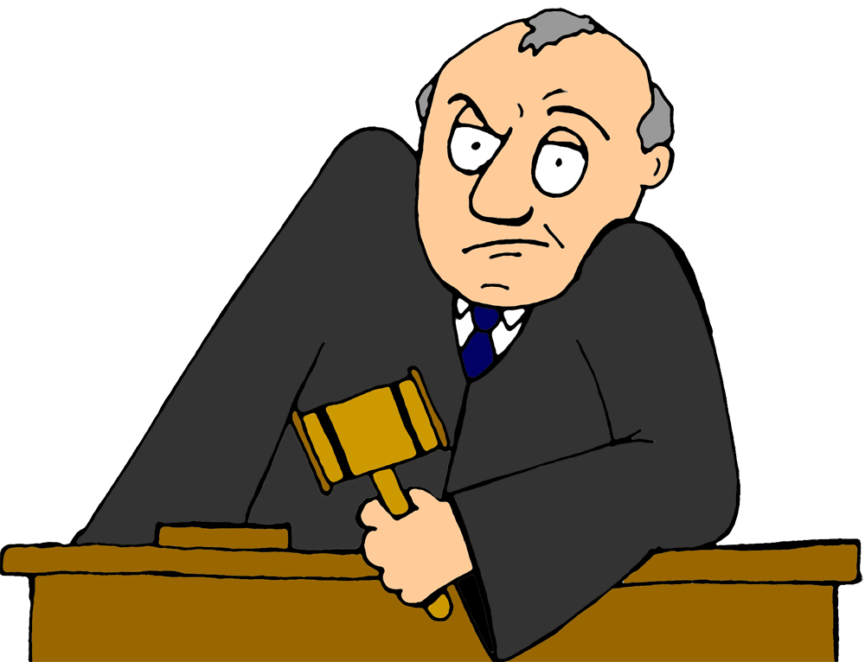
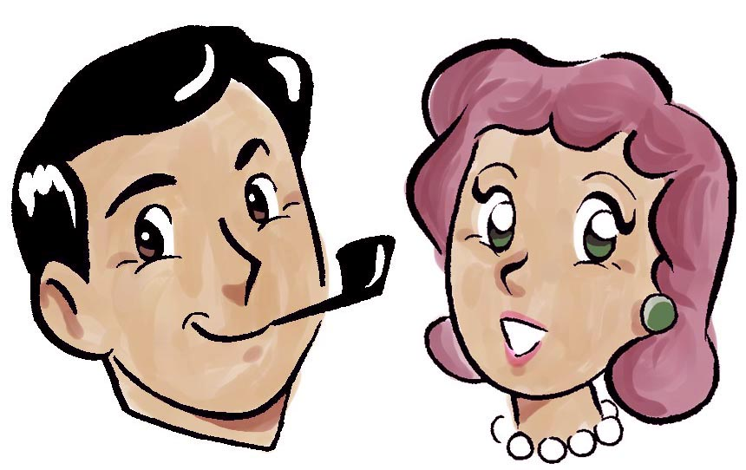

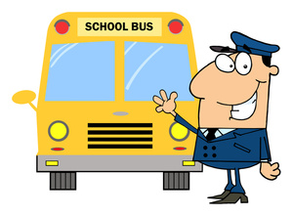

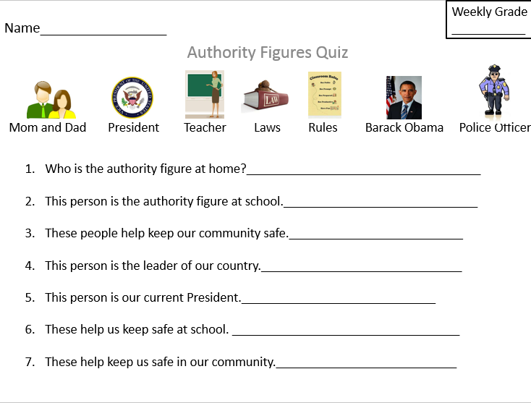
Attachment E

**This worksheet can be modified so that there is a blank square for each type of authority figure, and the student can place the picture for each question in the box under the question. The questions can be read aloud by the teacher, and then the students could either place the picture in the spot or glue it in the right spot.
Attachment F

How to Resolve a Conflict

Works Cited

Resources for Teaching Standard 1-C.1.01:
DePaola, T. (1975). Strega Nona: An old tale. Englewood Cliffs, New Jersey: Prentice-Hall.

Zike, D. (2002). Big Book of Social Studies for Elementary K-6. San Antonio, Texas: Dinah-Might Adventures, LP.

Resources for Teaching Standard 1-C1.0.2:
Allen Simon, C. (n.d.). Using the Think-Pair-Share Technique - ReadWriteThink. Retrieved April 20, 2015, from http://www.readwritethink.org/professional-development/strategy-guides/using-think-pair-share-30626.html

McDermott, M. Authority Versus Power. Social Studies Coalition of Delaware (Signature Lesson: Civics 1, K-3). Retrieved April 20, 2015, from http://www.sscde.org/lessons/files/C_K3_LES_AuthorityversusPower.pdf

Jones, M. (n.d.). Authority Figures Worksheet. Retrieved April 20, 2015, from https://www.teacherspayteachers.com/Product/Authority-Figures-Worksheet-487870

Resources for Teaching Standard 1-C1.0.3:
Calhoun ISD Social Studies Curriculum Design Project Building a School Community: Power of Authority. (Lesson 4). Retrieved April 20, 2015, from https://cisdsocialstudies.wikispaces.com/file/view/First+Grade+Building+a+School+Community+Unit+Complete.pdf

Neill, A., & Beith, L. (2002). The Recess Queen. New York, New York: Scholastic.

Resources for Teaching Standard 1-C2.0.1:
Dr. Seuss The Zax. (2012, May 16). Retrieved April 20, 2015, from https://www.youtube.com/watch?t=16&v=LaQXOrbqAbM

Conflict Resolution with "The Zax" (2012, March 18). Retrieved April 20, 2015, from
http://www.schoolcounselingbyheart.com/2012/03/18/introduce-conflict-resolution-with-the-zax/

Sesame Street: Robin Williams: Conflict. (2012, January 9). Retrieved April 20, 2015, from https://www.youtube.com/watch?v=Gl3e-OUnavQ&feature=youtu.be

Seuss, Dr. (1961). The Sneetches and Other Stories: The Zax. New York: Random House

Resources for Vocabulary Lesson
Betsy’s Kindergarten Adventures. (2014, August 22). Rules of the Road [Video file.] Retrieved from https://www.youtube.com/watch?v=pcqsY0QGLW8.

Marzano, R. and Pickering, D. (2005), Building Academic Vocabulary:Teacher’s Manual, Chapter 3, “Teaching the Selected Terms.”

Marzano, R. and Pickering, D. (2005), Building Academic Vocabulary: Teacher’s Manual, Chapter 4, “Review Activities and Games”

