Unit: Working with Money
Grade: 2nd
Purpose:
The purpose of this formative assessment is to give teachers and students an idea of how well students can apply their knowledge of the different units of U.S. currency to solve word problems involving the different units, and also to determine if the student uses the $ and ₵ symbols in the right context. Prior to this assessment, students will be introduced to the different units of money—dollar, quarter, dime, nickel, and penny, and how much each are worth in $ and ₵. After this assessment, students will move on to working with units of time. For this assessment, students will complete three different types of questions in this assessment—matching, multiple choice, and fill-in-the-blank-- to demonstrate their ability to correctly solve word problems about money. Once the students complete the assessment, the teacher will have individual conferences with each student to discuss both the strengths and areas for improvement in each of the students’ work. The students will also go through their assessment individually and keep a record of the questions they answered correctly and incorrectly. The combination of teacher feedback and self-reflection will give students an idea of how well they know the values of each unit of money, and also assess if they are able to apply that knowledge to solve word problems about money.

Standards/Benchmarks

CCSS.MATH.CONTENT.2.MD.C.8
Solve word problems involving dollar bills, quarters, dimes, nickels, and pennies, using $ and ¢ symbols appropriately. Example: If you have 2 dimes and 3 pennies, how many cents do you have?

CCSS.MATH.CONTENT.2.NBT.A.1
Understand that the three-digits of three-digit number represent amounts of hundreds, tens, and ones.
Learning Targets | Knowledge Items | Reasoning Items
I can solve word problems about different values of money. |  | 7,8,9,10,13
I can add and subtract values of money. |  | 1,2,3,4,5,6,7
I can use $ and ₵ in the right way. | 9,11,12,15,16,17
I can convert $ to ₵ and ₵ to $. | 9,10,11,12,16,17
I can understand and use hundreds, tens, and ones. |  | 1,2,3,4,5,6,18,19,20

Directions:

** The following directions are to be read aloud to the students before they take the assessment.**

Over the past few weeks, we have spent some time working with money and talking about how much a dollar, quarter, nickel, dime, and penny are worth. Now that we know about the different units of money and have spent some time solving word problems, we are going to check how well you can solve word problems on your own. Once you finish this assessment, you are going to go through the questions that you missed and we can talk about it so we can both get an idea of what you may need some help with before we move on to the next unit. This will also show me what I can do to help you do well.

This assessment will have 20 questions, and you will see 3 types of questions: multiple-choice, true/false, and fill-in-the blank. Each question will be worth 1 point.

When I pass out the paper, make sure you write your name and the date in the top right corner of your paper. You can write your answers on the line next to each question, and then once you answer the question, I want you to color in the face that best shows how you felt when you were working on the problem:
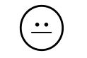
I am ready to move on.
I need more practice.
I don’t get it.

You have until lunch time to finish this assessment, so that gives you about 30 minutes to work on it. If you have questions, you can raise your hand and I will come over to you to answer your question. Once you are done, you can put your paper face-down in the bin on my desk. Once you are done, you can choose to work on a worksheet from your work folder that you have not yet finished, or you can use the time to silent read.

Remember, you will not be graded on this; it’s just to show me what you can do. Relax, take your time, and remember YOU’RE ALL ROCKSTARS!!!

Matching
Directions: For each question, add up the total and choose the right answer from the answer bank above the questions. Write the letter in the box on the left. You can use each letter only once. Then, color in the face that best shows how you feel about the problem. (1 point each)
Example:
A. Quarter B. Dollar C. Nickel D. Penny E. Dime
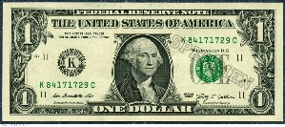
B

Answer Bank

A. $1.21 B. $1.12 C. $0.75 D. $2.26 E. $0.36 F. $0.46 G. $1.07 H. $2.16

- 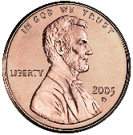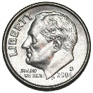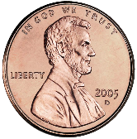

- 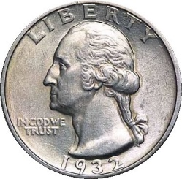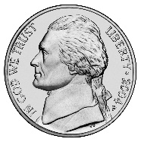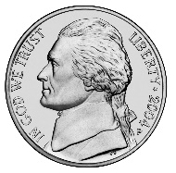

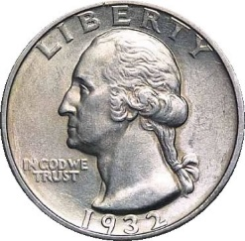

3.

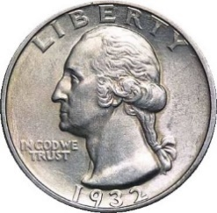
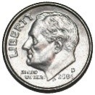
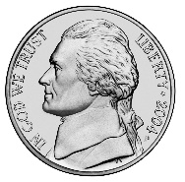

4.

5.

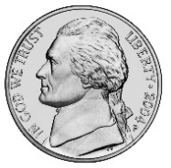

6.
Multiple Choice
Directions: Choose the letter that best answers the question and write that letter in the box. Then, color in the face that best shows how you feel about the problem. (1 point each)

Example:
B
How many months are in a year?
A. 6
B. 12
C. 7
D. 24

- If you have 3 quarters and 2 nickels, how many cents do you have?

- 35 ₵
- 85₵
- 75₵
- 5₵

- Katie wants to buy a candy bar for $1.86. She only has $1.12 in her pocket. What coins does she still need to buy the candy bar?

A. 3 quarters
B. 2 quarters, 2 dimes, and 1 nickel
C. 4 pennies and 3 quarters
D. 4 pennies, 2 quarters, and 4 nickels

9. I want to buy a gumball. If I have $2.15 and a gumball only costs 25₵, how much will I have left after I buy the gumball?

A. $1.90
B. 90₵
C. $0.75
D. 240 ₵

- I have 37₵ in my pocket. On my walk to school, I found two pennies, a nickel, and a quarter. How many dollars do I have after my walk?

A. $0.57
B. $0.32
C. $0.37
D. $0. 69
11. If I have 78₵, how many dollars do I have?

A. $7.80
B. $0.78
C. $78
12. If I have $5.87, how many cents do I have?

A. 587 ₵
B. 58.7 ₵
C. 5.87 ₵

13. My mom gave me $2.50 to spend at the store. I bought a bouncy ball for 75₵ and a stick of gum for 10₵. How much money do I have left?

A. $3.25
B. $1.65
C. $0.85
D. $3.35

Fill-in-the Blank
Directions: Write the answer that makes the most sense in the box on the right. Color in the face that best shows how you feel about the problem. (1 point each)

Example:
A Carrot is the color _______________.
orange

- To make a dollar, I need 4 ______________.

- I have three pennies, one nickel, and one quarter.

I have _______________ cents.

- 140₵ is the same as ____________ dollars.

- $0.91 is the same as __________ cents.

- To make a dime, I need ____________pennies.

- To make a dollar, I need _____________pennies.

- 50 pennies is worth the same as _____________ nickels.

Answer Key
Matching (six questions—1 point each)
1. B
2. E
3. D
4. C
5. A
6. F
Multiple Choice (seven questions—1 point each)
7. B
8. D
9. A
10. D
11. B
12. A
13. B
Fill-in-the-blank (seven questions—1 point each)
14. quarters
15. 33
16. 1.40
17. 91
18. 10
19. 100
20. 10

Student Feedback/ Reflection
** For this portion of the assessment, the teacher will meet with each student individually to ask each student for feedback on the assessment. Students will use their indication of how they felt for each question on the assessment to help guide their responses to the feedback questions below. The questioning will be done orally. There is room for teacher notes in the spaces below.**
Which questions were the easiest for you? Why?

Which Questions were the hardest for you? Why?

What can I do to help you understand those questions better?

Is there anything you want more practice on?

What Now?
Directions: Read the learning targets below and color in the face that describes how well you feel you met the learning target.

I can solve word problems about different values of money.
I can add and subtract values of money.
I can use $ and ₵ in the right way.
I can convert $ to ₵ and ₵ to $.
I can understand and use hundreds, tens, and ones.

